LAB13 Analyze server system status

Name: Truong Dang Truc Lam Students ID: B2111933 Class: M04

1. System environment for analyzing

| Window tool | Linux command | Remarks |
| --- | --- | --- |
|  |  |  |
| Process Explorer | uname |  |
| CurrPorts | hostname |  |
| Process Monitor | ifconfig |  |
| Tcpview | df -h |  |
|  |  |  |

1. Select one model for analyzing server system status

[Model A] Windows

1. Choose Sysinternals Security Utilities
2. Execute the tool

[Model B] Linux

1. Select Linux and check the Linux command

Here are some essential Linux commands to check system information:

**General System Information:** uname -a, lsb_release -a, cat /etc/issue, hostname

**Hardware Information:** lshw, lspci, lsusb, dmidecode, cpuinfo

**Network Information:** ifconfig, ip addr, netstat

**Disk Information:** df -h, du -sh /*, fdisk -l

**Memory Information:** free -h, vmstat

**Process Information:** top, ps aux, htop

1. Execute the command
2. uname

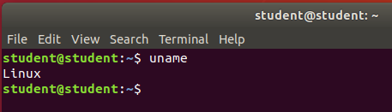  
uname

1. hostname

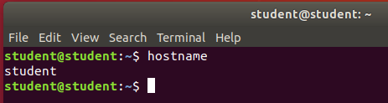  
hostname

1. ifconfig

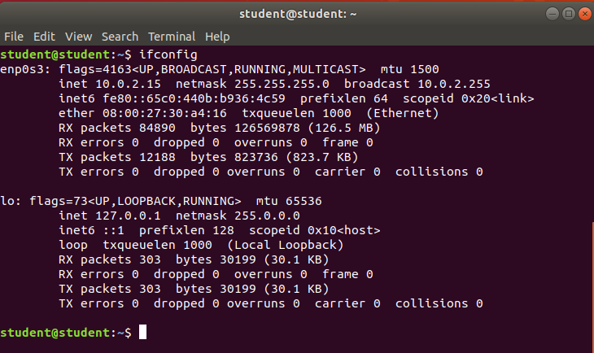  
ifconfig

1. df -h

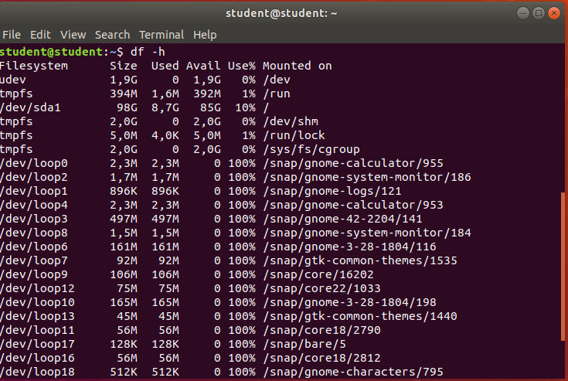  
df -h

1. Explain each command
2. **uname:** Displays detailed kernel information, including architecture, version, and hostname.
3. **hostname:** Displays the current hostname.
4. **ifconfig:** Displays network interface information.
5. **df -h:** Displays disk usage information in human-readable format.